- The reintroduction of Labour Force Survey (LFS) data alongside revised population estimates revealed a UK labour market with more people in work, but a lower employment rate, and a higher inactivity rate than previously thought. But these estimates will potentially change again when the improved LFS appears later this year, so assessing the jobs market remains a challenge.
- An upbeat services PMI for January was accompanied by a cooling in cost and price pressures, while the same month's KPMG/REC report pointed to pay growth softening. Alongside the latest comments from MPC members, the ingredients remain in place for rates to start falling in Q2.
The Office for National Statistics' decision last autumn to suspend the Labour Force Survey, used to measure key jobs market indicators such as employment and unemployment, made it impossible to get a reading of the true state of the jobs market. But the ONS reintroduced some LFS data this week as well as reweighting the results using the latest census estimates on the size and composition of the UK population.
Our scepticism about the quality of the experimental data that the ONS has published since October in place of the LFS was reinforced by differences between the new reweighted LFS numbers and the experimental measures. The unemployment rate is now estimated to have fallen over the second half of last year, rather than stabilising as the experimental data had suggested (Chart 1). The employment rate dropped in recent months rather than increasing. And the new numbers show inactivity rising in H2 2023 rather than holding on to the decline of earlier last year.
Some of these movements appear to be driven largely by demographics. A bigger population than previously thought has raised the number of people estimated to be in work. But with the rise in the population accounted for disproportionately by younger people and women, who on average are less likely to be in work, inactivity has also been revised up. That even more people are now thought to be out of the workforce due to ill-health (sitting at a record 2.8m) also contributed to the larger inactive population.
The new numbers resolve one issue with the old LFS estimates – being based on too small a population.
Chart 1: New LFS estimates suggest the jobless rate fell in H2 2023
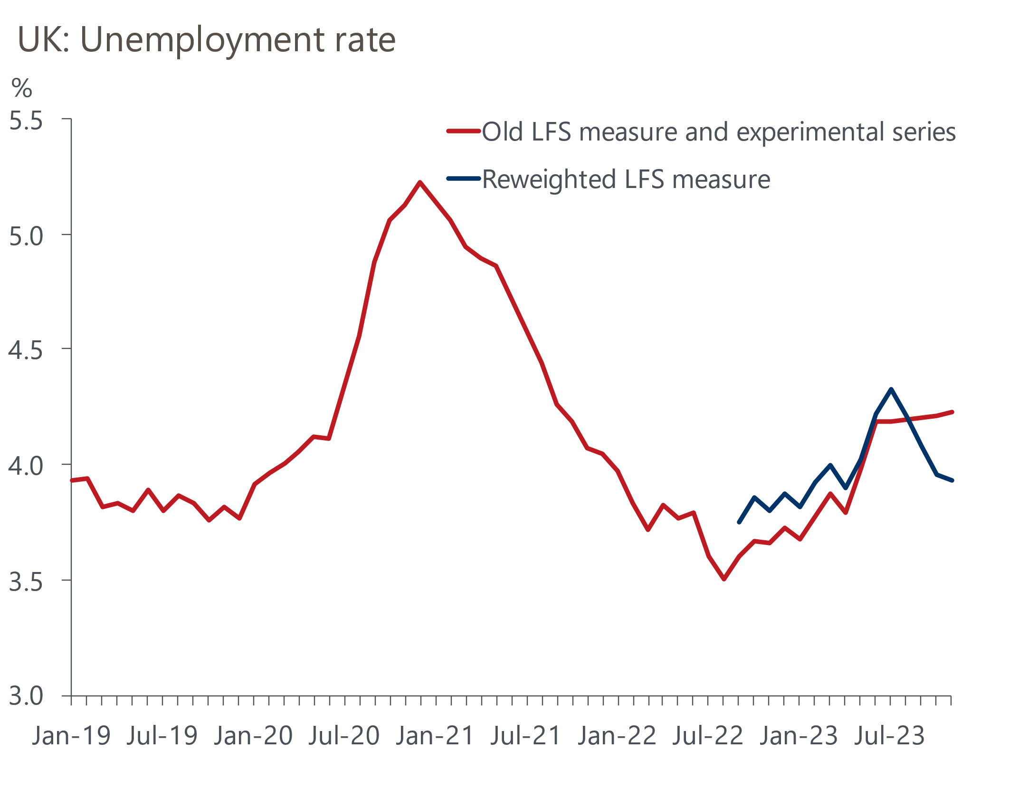
Source: Oxford Economics/ONS

But they don't yet fully reflect what the ONS anticipates will be improvements to response levels and rates from the reintroduction of face-to-face interviews and an increase in the number of people sampled. Consequently, the ONS advises "caution" in interpreting short-term movements in the new headline series. In addition, our conversations with the ONS suggest that many of the more detailed LFS series will initially either remain absent or have time series that contain discontinuities. These issues will be resolved over time, but for some series this may not happen until the ONS's 'Transformed Labour Force Survey' (TFLS) appears later in the year. And with data from the TFLS now not due to be released until July, versus the original planned date of spring, uncertainty about the jobs market will persist for some time yet.
Regarding jobs, January's S&P Global/CIPS services survey offered some good news, with the rate of job creation the fastest since July 2023. A services PMI of 54.3 signalled the strongest growth in activity since last May. This lifted January's composite PMI to 52.9 from December's 52.1, also an eight-month high.
Still, that the survey covers only the private sector means it won't have captured the economic impact of strikes by junior doctors in early January (Chart 2). And this week's other survey evidence wasn't all so positive. January's construction PMI of 48.8 was below the 50 'no-change' mark for the fifth month in a row. And the BRC's retail survey showed annual growth in retail sales values slowing in January.
Chart 2: The economy's performance may not be as robust as January's PMI suggested
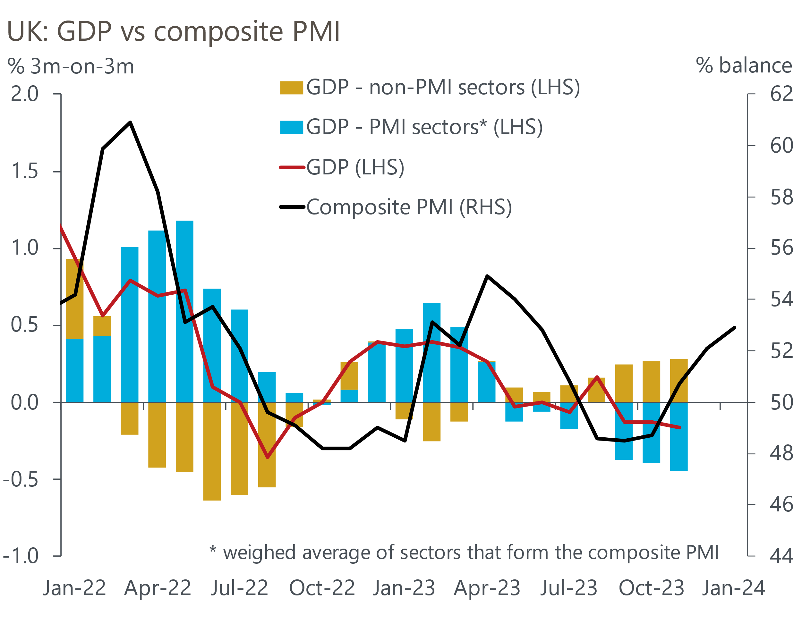
Sources: Oxford Economics/ONS/S&P Global/CIPS
Positive developments around inflation were less ambiguous. According to S&P Global/CIPS, services input price inflation rose at the joint slowest pace in almost three years. Output price inflation was the weakest since last September. Pay growth continued to be the main driver of higher costs, although January's KPMG/REC Report on Jobs measure of salaries for new starters, which the BoE notes has been a good past predictor of private sector pay growth, was the slowest in 34 months and below the long-run average.
A more reassuring picture on pay was one factor cited by MPC member Swati Dhingra in an interview in explaining her vote to cut Bank Rate last week. At the other end of the dove-hawk spectrum, Catherine Mann, who voted for a rate rise in January, set out her case in a speech. A loosening in financial conditions and the ongoing risk of inflation persistence were among reasons Mann gave in support of tighter policy.
Comments by BoE chief economist Huw Pill and deputy governor Sarah Breeden are probably of more interest in discerning the future direction of monetary policy, given that both are members of the key internals group. Pill was explicit that it was a question of "when, rather than if" rates will be cut. And he added that the BoE did not need to see underlying inflation fall to 2% before loosening policy, because policy would still be “restrictive” even after a slight reduction in borrowing costs. Meanwhile, Breeden said that she had "become less concerned that rates might need to be tightened further" and that her focus "has shifted to thinking about how long rates need to remain at their current level.” Overall, smoke signals from the MPC remain consistent with our view that Bank Rate will be cut from Q2 onwards.

The week ahead
A succession of high-profile data releases begins with labour market data for the end of last year. The new numbers will reinstate reweighted LFS estimates incorporating the latest view of the size and composition of the population and include revised historical estimates back to 2011.
The indicative estimates published on February 5 showed an unemployment rate of 3.9% in the three months to November. Surveys pointed to weaker demand for workers towards the end of 2023 and the economy looks to have been broadly stagnant. As a result, we think the jobless rate may have ticked up to 4% in Q4 2023, although continued issues with response levels and rates mean the ONS estimates will need to be treated with caution.
Meanwhile, the slowdown in pay growth which began last summer probably continued into the close of 2023. Headline (three-month average of the annual rate) total pay growth in November eased to a seven-month low of 6.5%. With September's unusually strong single-month rise falling out of the three-month comparison and some alternative pay measures, such as that from the KPMG/REC Report, more subdued of late, headline growth in total pay in December is forecast to have slowed to 5.5%.
It's touch-and-go whether GDP suffered a second successive quarterly contraction in Q4 2023. GDP data for December will confirm whether that was the case. The outcome for that month is also looking finely balanced. On the one hand, that December's composite PMI moved further into expansionary territory suggested momentum in private sector activity built at the end of last year. On the other, retail sales fell sharply in the last month of 2023 and NHS strikes likely weighed on public sector output. On balance, we think GDP rose 0.1% in December, which would leave the economy flat in Q4.
What had been a steady fall in inflation last year was interrupted in December, when the CPI measure rose to 4% from November's 3.9%. Base effects, reflecting some large and unusual falls in several services prices in January 2023 and the rise in Ofgem's energy price cap in January this year means we think inflation will have ticked up again. CPI inflation in January is forecast at 4.3%.
Finally, we think retail sales in January will have made up some of the previous month's shock fall. Sales volumes dropped a sizeable 3.2% m/m in December, the biggest monthly decline since January 2021. But the outturn was far weaker than results from relevant business surveys and the official retail series is notoriously noisy. As a result, we anticipate that sales volumes bounced back in January, rising 2% m/m.

Table 1: Week ahead calendar
Date | Events | Period | Measure | Unit | Previous | Forecast
Feb 13 | ILO unemployment | Oct-Dec | Rate | % | 3.9 | 4.0
Feb 13 | Average earnings (total pay) | Dec | 3m, y/y | % | 6.5 | 5.5
Feb 13 | Average earnings (regular pay) | Dec | 3m, y/y | % | 6.6 | 6.1
Feb 14 | CPI inflation | Dec | m/m | % | 0.4 | -0.3
Feb 14 | CPI inflation | Jan | y/y | % | 4.0 | 4.3
Feb 14 | RPI inflation | Jan | m/m | % | 0.5 | 0.4
Feb 14 | RPI inflation | Jan | y/y | % | 5.2 | 5.7
Feb 14 | Producer input prices | Jan | m/m | % | -1.2 | 0.0
Feb 14 | Producer input prices | Jan | y/y | % | -2.8 | -3.1
Feb 14 | Producer output prices | Jan | m/m | % | -0.6 | -0.1
Feb 14 | Producer output prices | Jan | y/y | % | 0.1 | -0.5
Feb 14 | Land Registry house prices | Dec | y/y | % | -2.1 | -1.4
Feb 15 | GDP | Dec | m/m | % | 0.3 | 0.1
Feb 15 | GDP | Dec | 3m/3m | % | -0.2 | 0.0
Feb 15 | Index of services | Dec | m/m | % | 0.4 | 0.0
Feb 15 | Index of services | Dec | 3m/3m | % | -0.1 | 0.2
Feb 15 | Manufacturing output | Dec | m/m | % | 0.4 | 1.5
Feb 15 | Manufacturing output | Dec | y/y | % | 1.2 | 2.4
Feb 15 | Industrial production | Dec | m/m | % | 0.3 | 1.2
Feb 15 | Industrial production | Dec | y/y | % | -0.1 | 1.0
Feb 15 | Construction output | Dec | m/m | % | -0.3 | 0.1
Feb 15 | Construction output | Dec | y/y | % | 0.9 | -1.1
Feb 15 | UK trade | Dec | Trade balance | £bn | -1.4 | -2.3
Feb 15 | UK trade | Dec | Visible balance | £bn | -14.2 | -14.9
Feb 16 | Retail sales inc fuel | Jan | m/m | % | -2.3 | 2.0
Feb 16 | Retail sales inc fuel | Jan | y/y | % | -3.2 | -1.3
Source: Oxford Economics

Key forecasts
Table 2: UK forecast overview
(Annual percentage changes unless specified)
 | 2021 | 2022 | 2023 | 2024 | 2025 | 2026
GDP | 8.7 | 4.3 | 0.3 | 0.6 | 1.6 | 1.9
Private consumption | 7.5 | 4.8 | 0.6 | 0.9 | 1.8 | 1.9
Fixed investment | 7.4 | 8.0 | 2.3 | -3.2 | 0.5 | 2.8
Government consumption | 14.9 | 2.3 | 0.6 | 4.3 | 2.1 | 1.6
Exports of goods and services | 4.9 | 9.0 | -0.3 | 0.1 | 2.8 | 2.4
Imports of goods and services | 6.1 | 14.6 | -1.3 | 2.0 | 3.3 | 3.0
Industrial Production | -3.9 | -3.5 | -0.4 | 0.4 | 0.9 | 1.5
Consumer prices | 2.6 | 9.1 | 7.3 | 2.1 | 1.5 | 1.9
Unemployment rate (%) | 4.5 | 3.7 | 4.1 | 4.5 | 4.3 | 4.0
Current a/c balance (% of GDP) | -0.5 | -3.1 | -2.6 | -2.5 | -2.6 | -2.7
Government balance (% of GDP) | 7.2 | 4.4 | 5.2 | 3.2 | 2.8 | 2.4
Cen. bank policy rate (%, EOP) | 0.25 | 3.50 | 5.25 | 4.50 | 3.50 | 2.50
10yr govt. bond yield (%, EOP) | 0.97 | 3.67 | 3.54 | 3.63 | 3.43 | 3.00
Exchange rate (US$ per £, EOP) | 1.35 | 1.20 | 1.27 | 1.27 | 1.29 | 1.32
Exchange rate (euro per £, EOP) | 1.19 | 1.13 | 1.15 | 1.17 | 1.16 | 1.15
Source: Oxford Economics
Table 3: Quarterly forecasts for the UK
 | 2023 |  |  |  | 2024
 | Q1 | Q2 | Q3 | Q4 | Q1 | Q2 | Q3 | Q4
GDP (% year) | 0.4 | 0.3 | 0.3 | 0.2 | 0.2 | 0.4 | 0.8 | 1.0
CPI inflation (% year) | 10.2 | 8.4 | 6.7 | 4.2 | 3.7 | 1.6 | 1.7 | 1.5
Bank Rate (%, EOP) | 4.25 | 5.00 | 5.25 | 5.25 | 5.25 | 5.00 | 4.75 | 4.50
10yr gilt yield (%, EOP) | 3.47 | 4.39 | 4.46 | 3.54 | 3.75 | 3.65 | 3.65 | 3.63
US$ per £ (EOP) | 1.24 | 1.27 | 1.22 | 1.27 | 1.26 | 1.26 | 1.26 | 1.27
Euro per £ (EOP) | 1.14 | 1.17 | 1.15 | 1.15 | 1.17 | 1.17 | 1.17 | 1.17
Source: Oxford Economics

Latest Country Economic Forecast:
January 18, 2024

Recent publications

Data Insights
Services activity strengthens, as inflation cools
Red sea disruption raises manufacturing input costs
Mortgage activity picked up modestly in December
Flash PMIs suggest economy began 2024 on a better footing
December's fiscal deficit was well below expectations

Research Briefings
BoE suggests rate cuts are coming…but not quite yet
Housing market on course for a soft landing
MPC preview – A change of tone, but not of policy
Nowcast points to continued labour market resilience
Will the MPC cut fast or slow?

Contacts

Oxford Economics' UK team
- Andrew Goodwin - Chief UK Economist - agoodwin@oxfordeconomics.com
- Edward Allenby - UK Economist - eallenby@oxfordeconomics.com

